Measuring cup
# Source: AI Source: Provided by: [Data Path: Persons Table -> ID Column: 1, Name_En Column: Motasem Essam] -> From: [ChatGPT] on [7/17/2026]
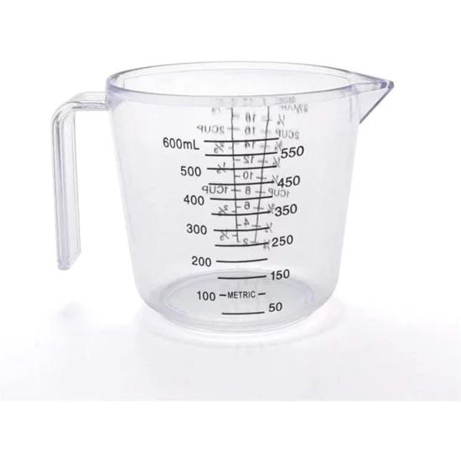
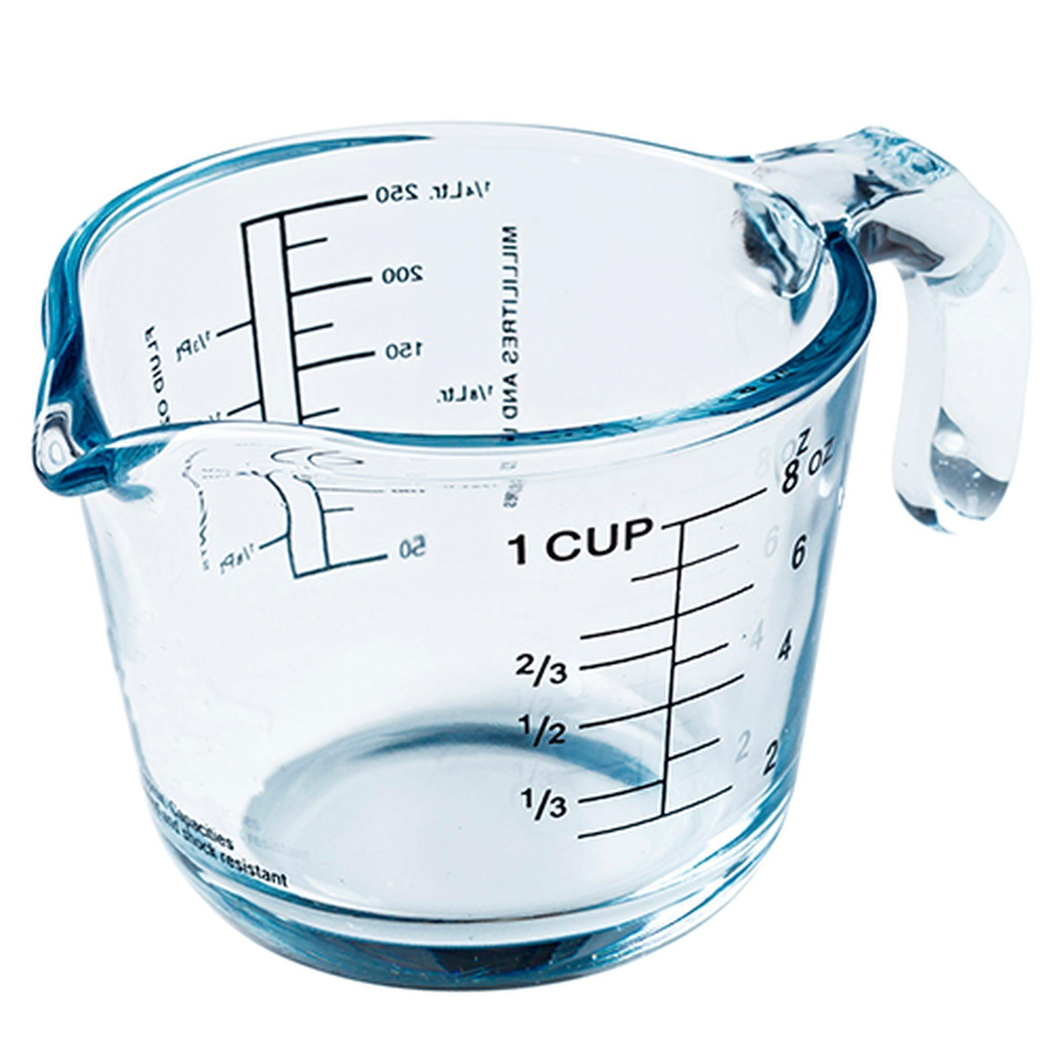
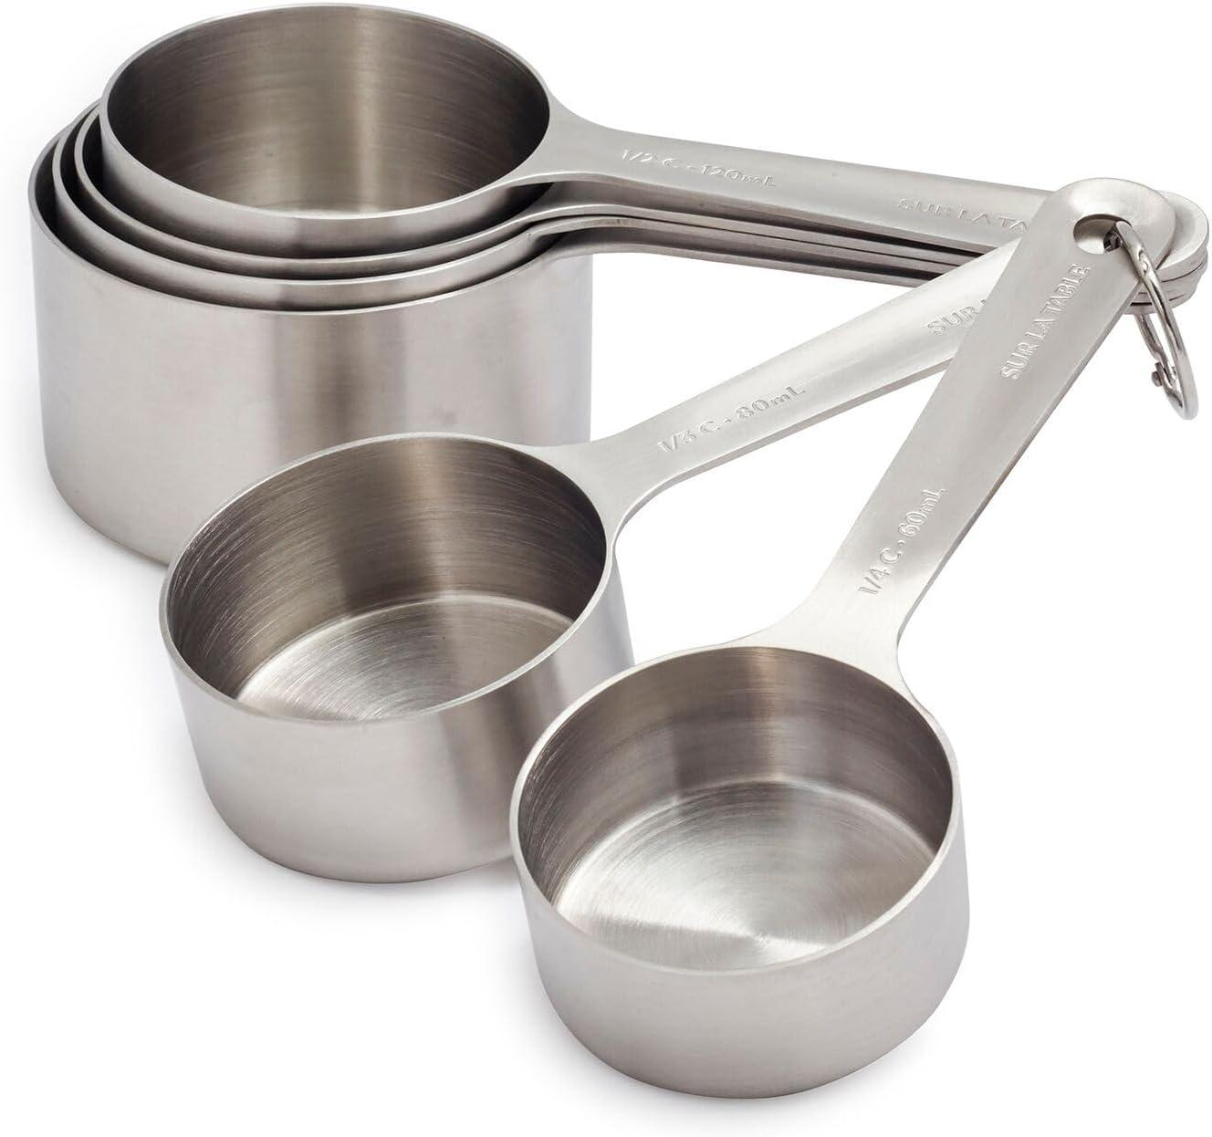
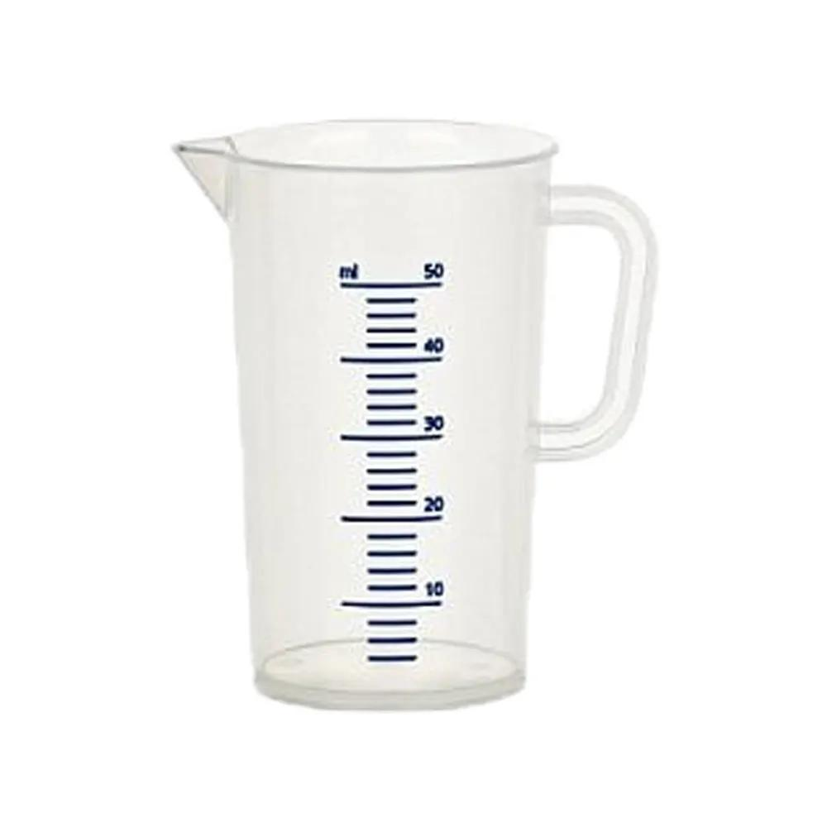
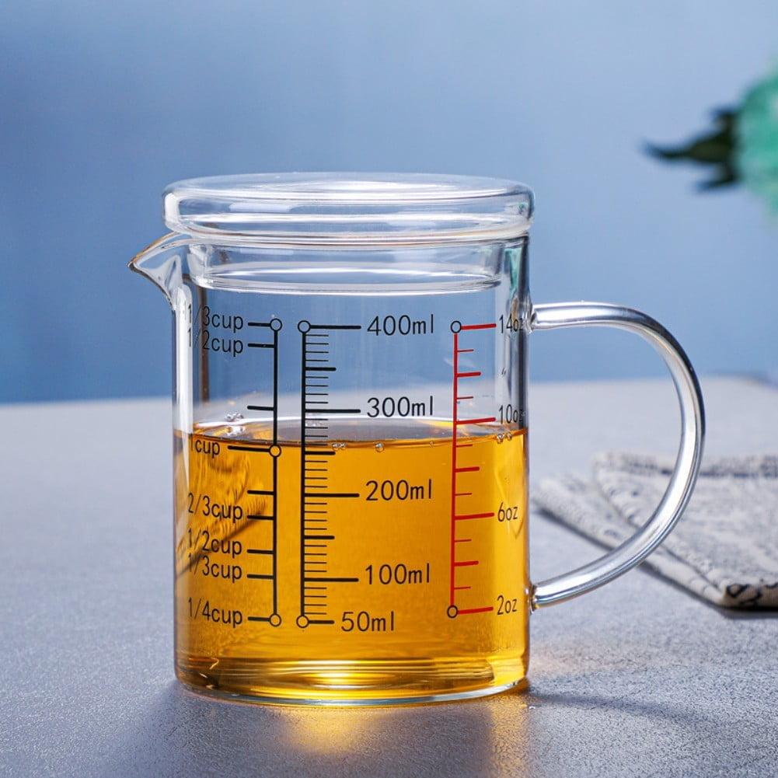
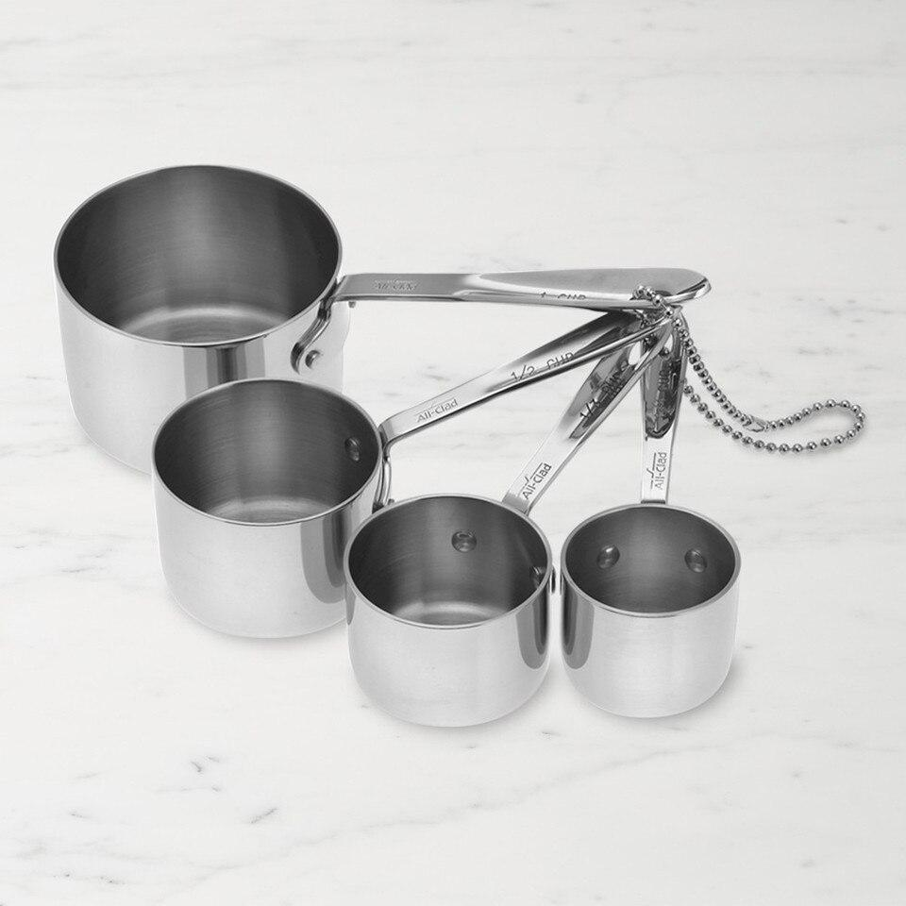
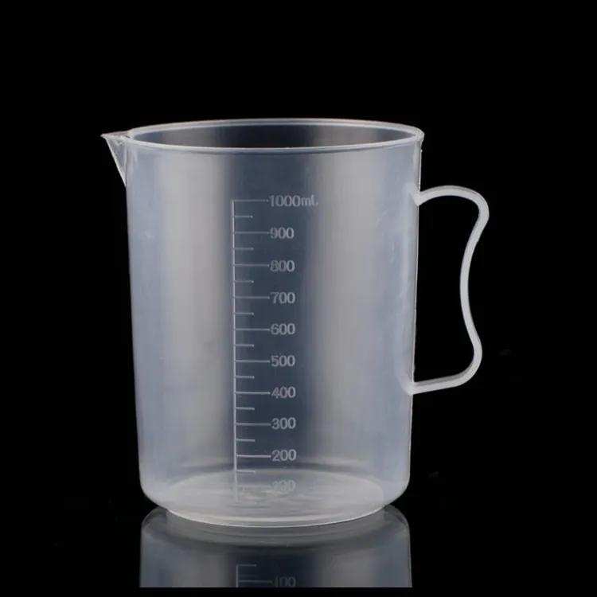
A Measuring Cup is a volume-measuring instrument used to measure a specified quantity of liquids or dry ingredients. It is commonly used in cooking, baking, laboratories, pharmaceuticals, food processing, education, and industrial applications.
Measuring cups are graduated with volume markings, allowing users to accurately measure ingredients or liquids before mixing, heating, or processing.

Definition
# Source: AI Source: Provided by: [Data Path: Persons Table -> ID Column: 1, Name_En Column: Motasem Essam] -> From: [ChatGPT] on [7/17/2026]
A Measuring Cup is a graduated container designed to measure and dispense known volumes of liquids or dry materials accurately.

Purpose
# Source: AI Source: Provided by: [Data Path: Persons Table -> ID Column: 1, Name_En Column: Motasem Essam] -> From: [ChatGPT] on [7/17/2026]
A measuring cup is used to:
- Measure liquid volumes.
- Measure dry ingredient volumes.
- Prepare recipes accurately.
- Mix ingredients.
- Measure laboratory liquids (non-precision work).
- Portion food ingredients.
- Support educational demonstrations.

Principle of Operation
# Source: AI Source: Provided by: [Data Path: Persons Table -> ID Column: 1, Name_En Column: Motasem Essam] -> From: [ChatGPT] on [7/17/2026]
A measuring cup determines volume by comparing the liquid or material level with graduated markings printed or engraved on the container.
The measured volume corresponds to the graduation reached by the liquid's surface (for liquids, read at the bottom of the meniscus when applicable).

Main Components
# Source: AI Source: Provided by: [Data Path: Persons Table -> ID Column: 1, Name_En Column: Motasem Essam] -> From: [ChatGPT] on [7/17/2026]
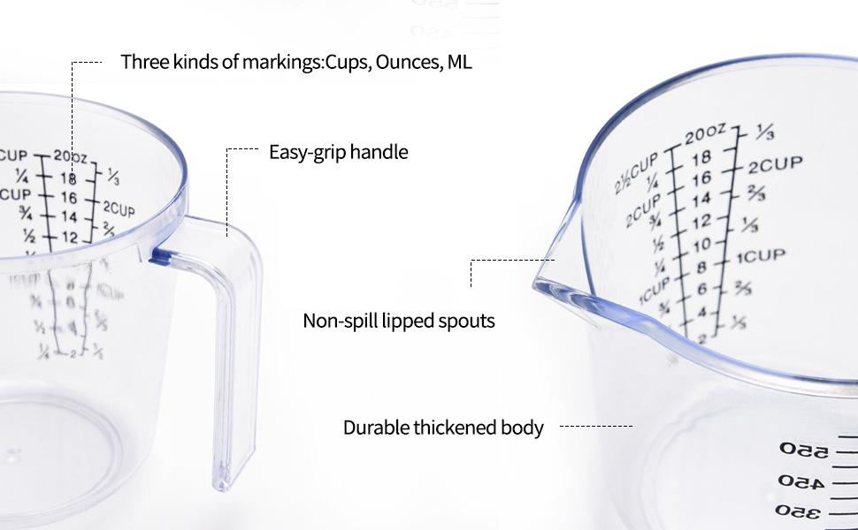
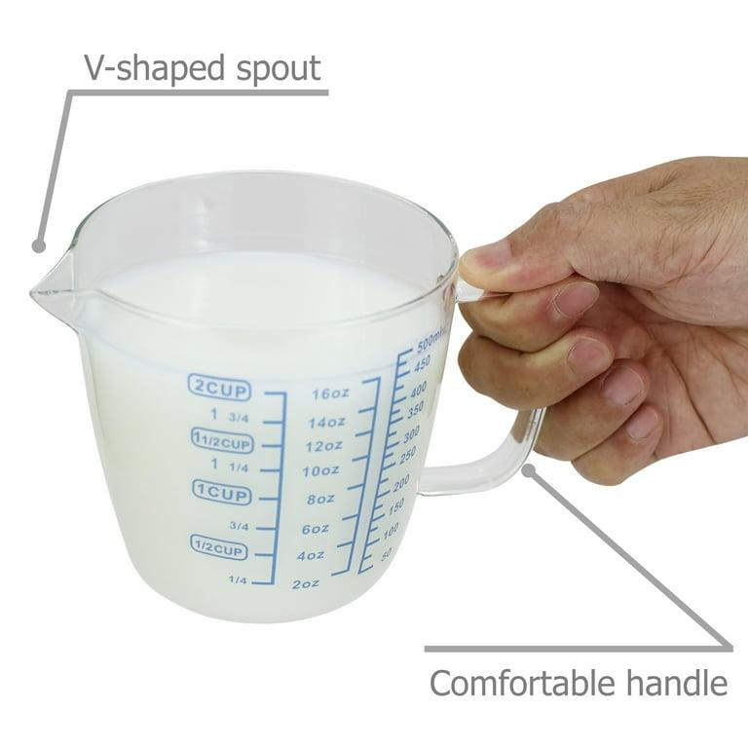
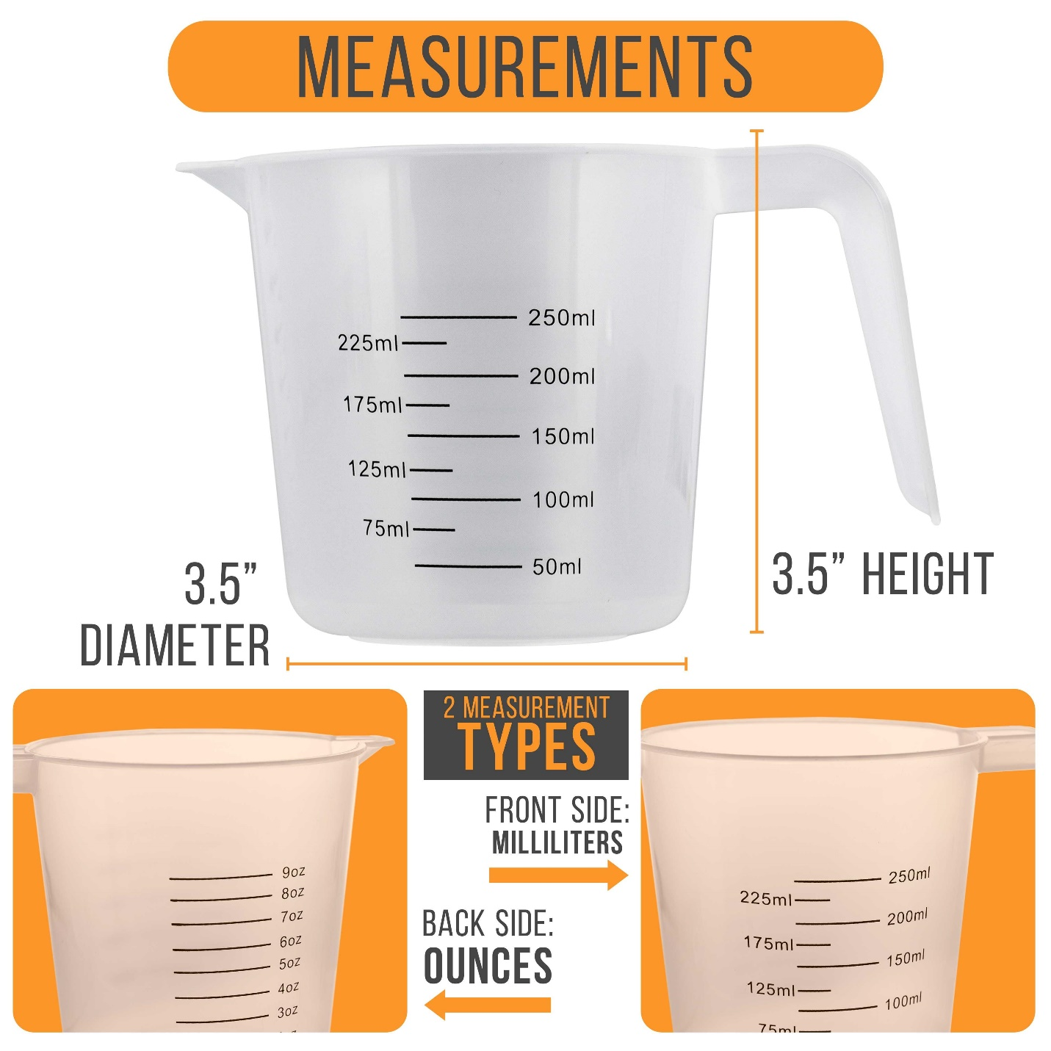
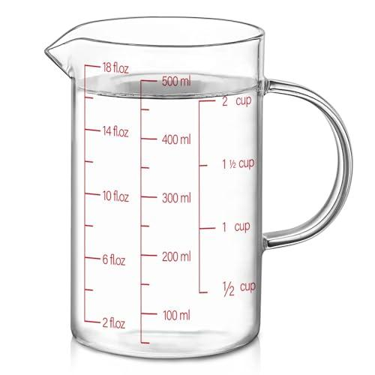
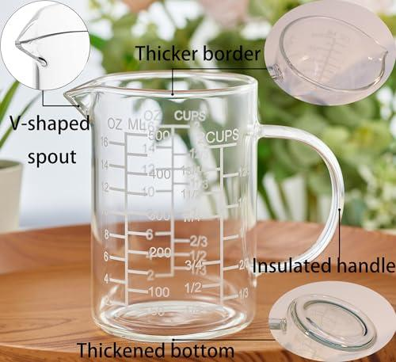
A typical measuring cup consists of:
- Cup body
- Graduated measurement scale
- Handle
- Pouring spout
- Flat base

Types of Measuring Cups

1. Plastic Measuring Cup
# Source: AI Source: Provided by: [Data Path: Persons Table -> ID Column: 1, Name_En Column: Motasem Essam] -> From: [ChatGPT] on [7/17/2026]

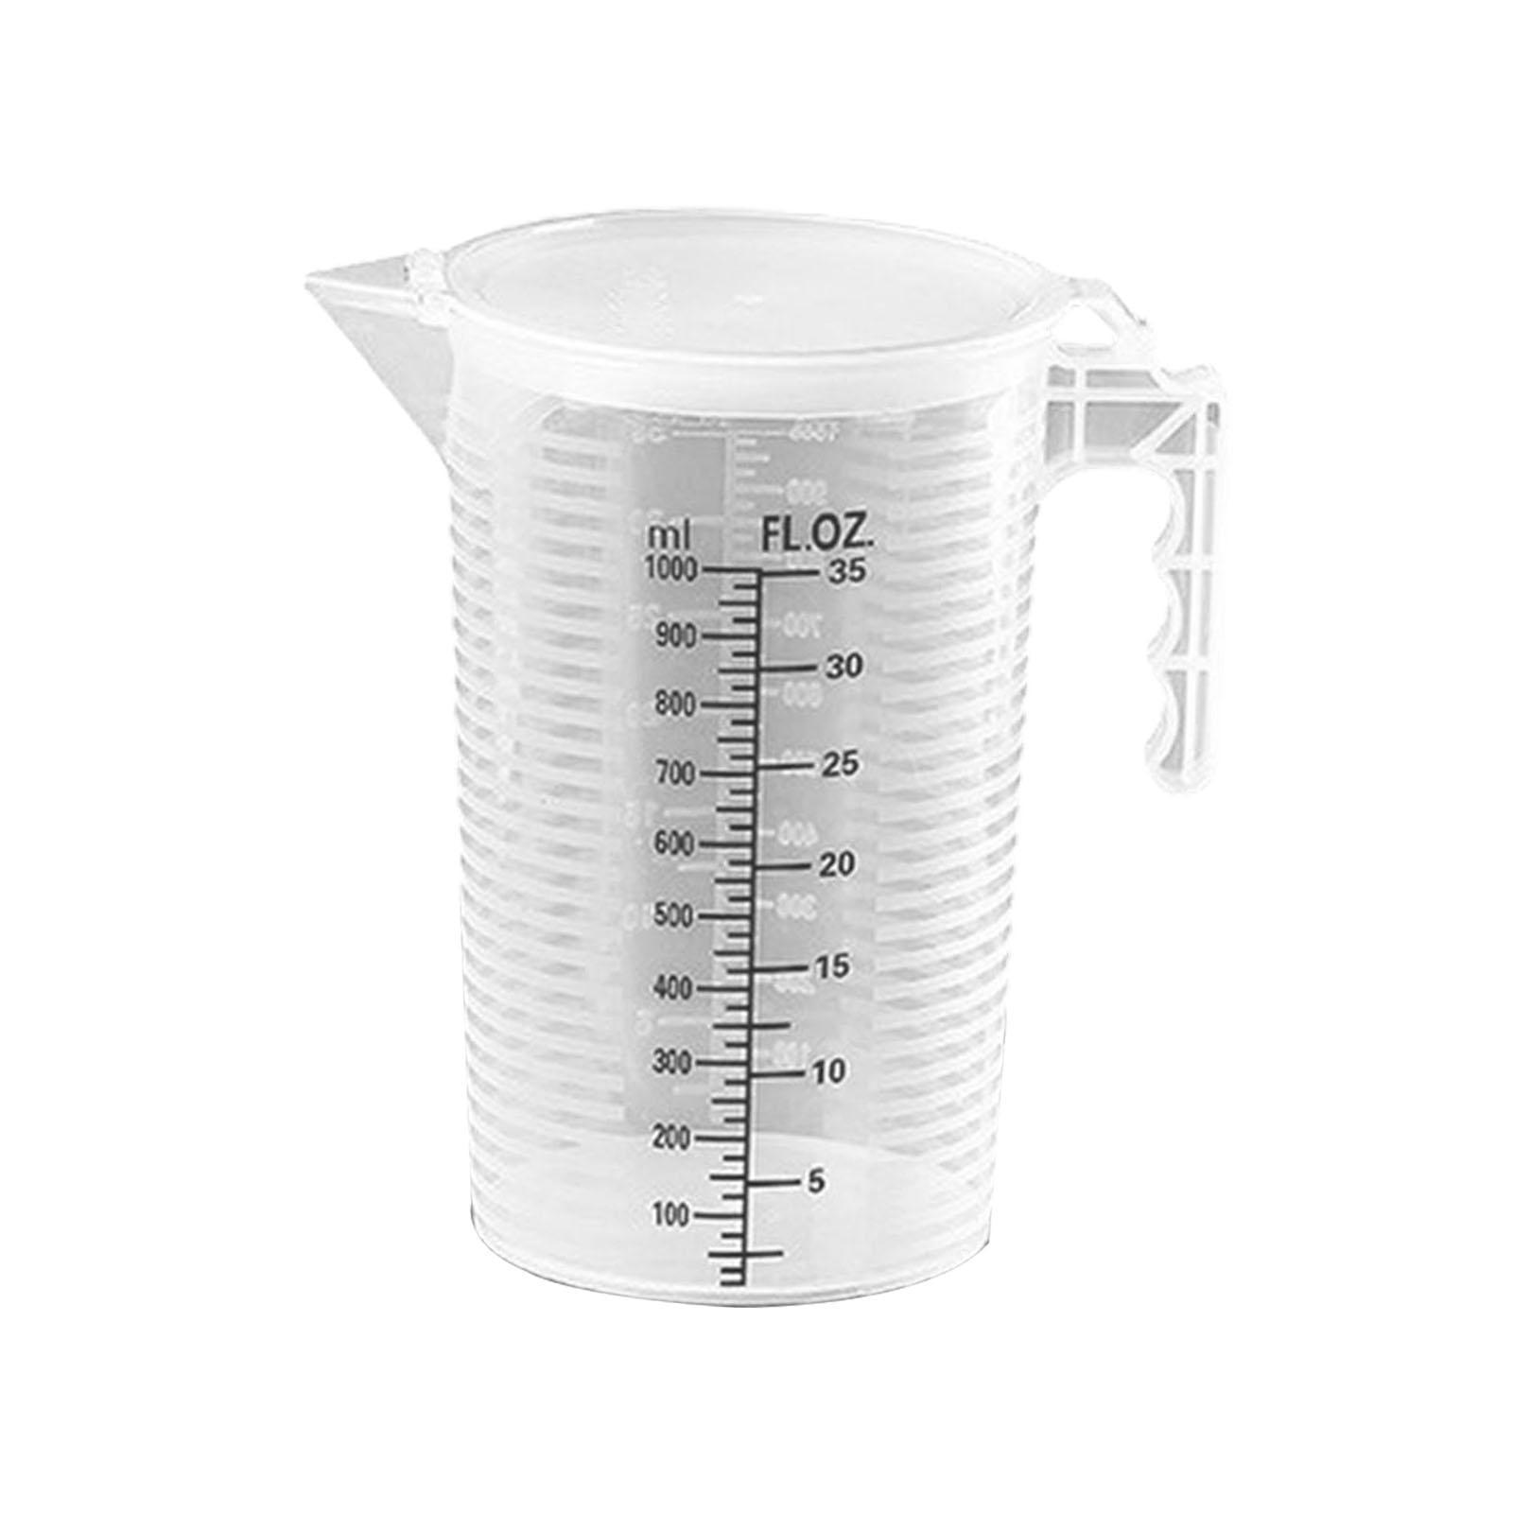
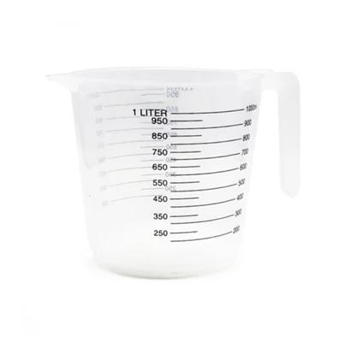
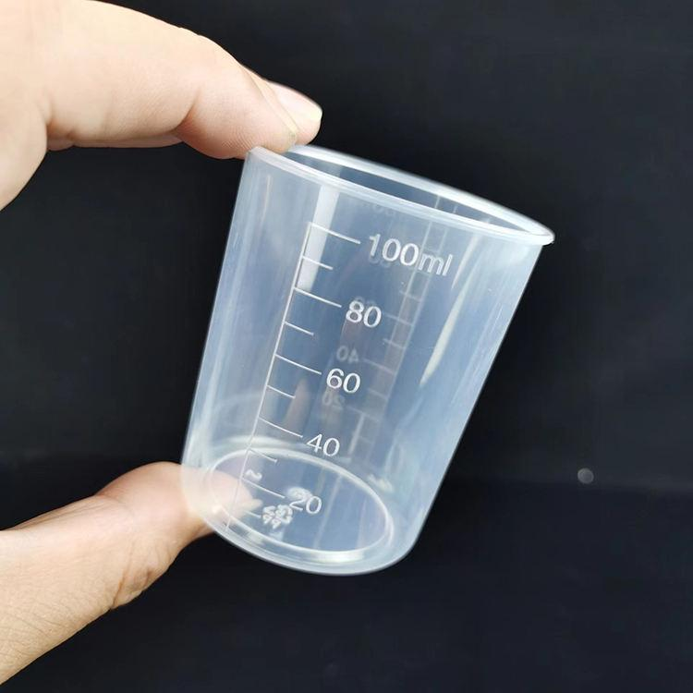
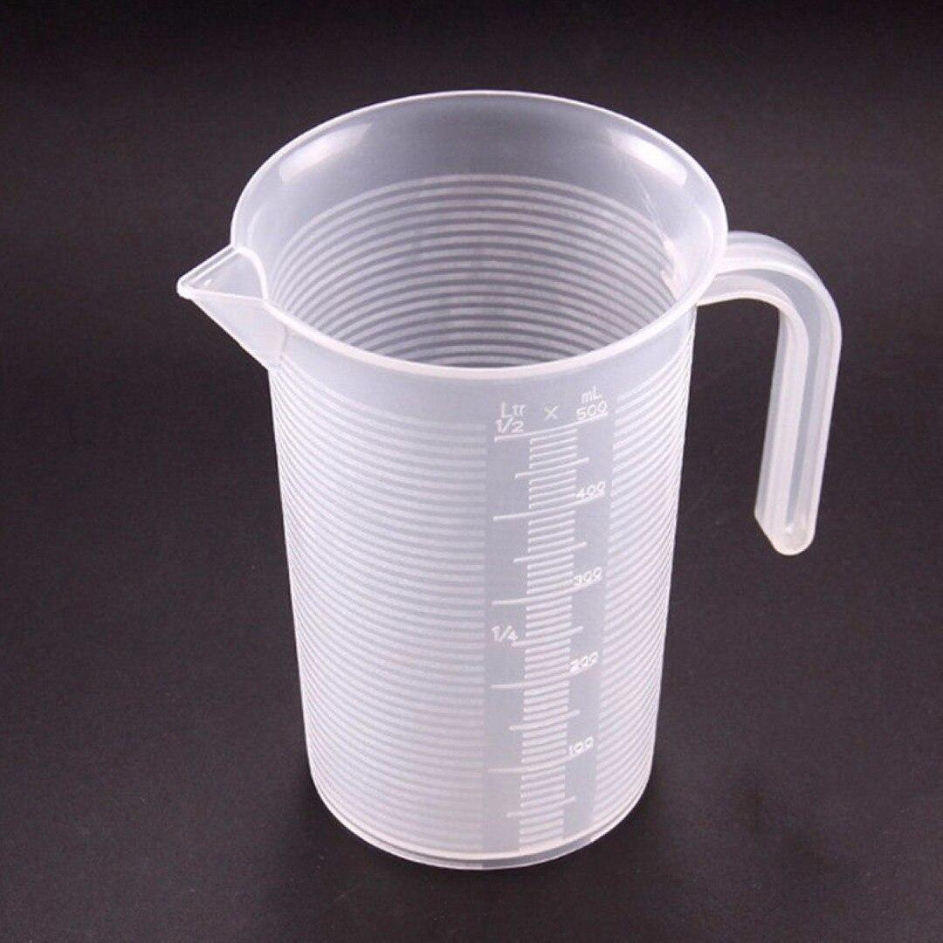
Description
Made from transparent plastic with printed measurement markings.
Features
- Lightweight
- Affordable
- Easy to read
- Break-resistant
Applications
- Home kitchens
- Schools
- General food preparation

2. Glass Measuring Cup
# Source: AI Source: Provided by: [Data Path: Persons Table -> ID Column: 1, Name_En Column: Motasem Essam] -> From: [ChatGPT] on [7/17/2026]


Description
Made from heat-resistant glass.
Features
- Microwave safe (many models)
- Chemically resistant
- Transparent
- Durable
Applications
- Cooking
- Baking
- Laboratory demonstrations

3. Stainless Steel Measuring Cup
# Source: AI Source: Provided by: [Data Path: Persons Table -> ID Column: 1, Name_En Column: Motasem Essam] -> From: [ChatGPT] on [7/17/2026]


Description
Usually supplied as a set of fixed-capacity cups.
Features
- Highly durable
- Corrosion resistant
- Long service life
Applications
- Baking
- Commercial kitchens
- Food preparation

4. Laboratory Measuring Cup (Graduated Cup)
# Source: AI Source: Provided by: [Data Path: Persons Table -> ID Column: 1, Name_En Column: Motasem Essam] -> From: [ChatGPT] on [7/17/2026]

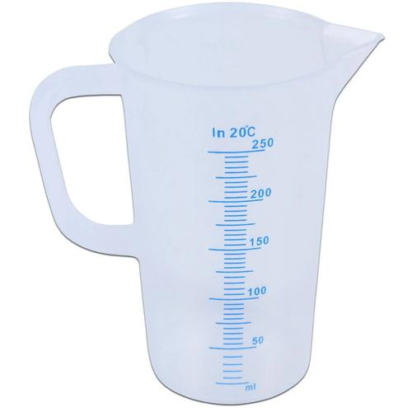
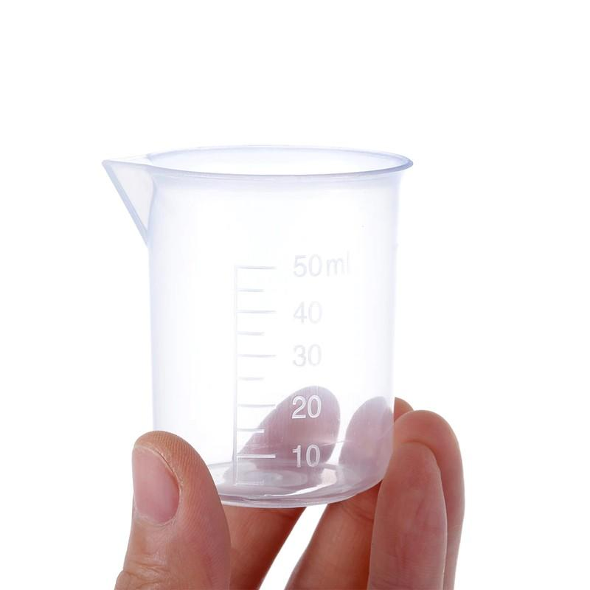
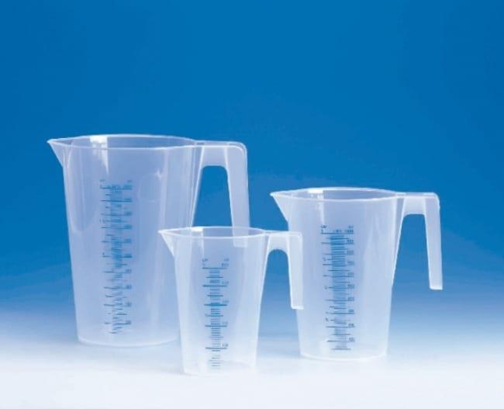
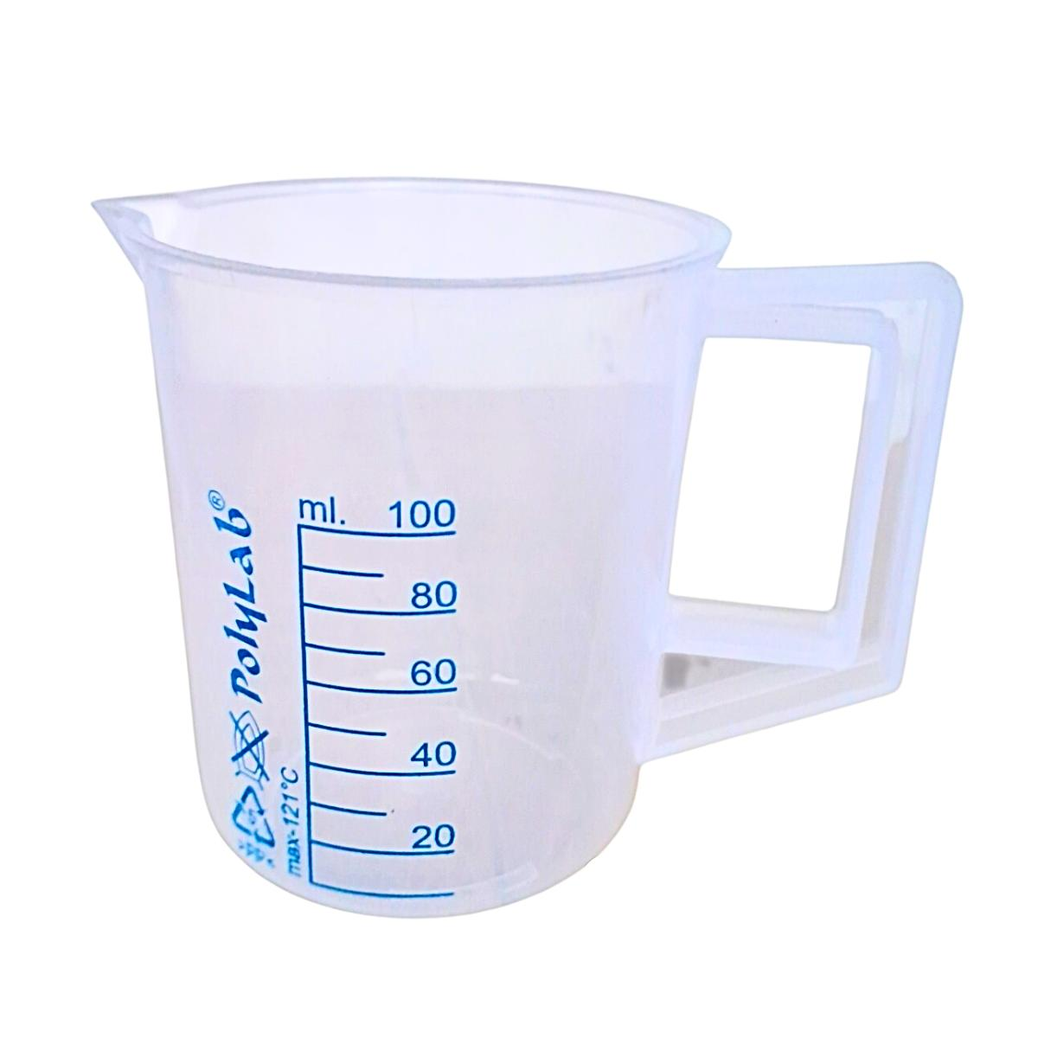
Description
Used for approximate liquid measurements in laboratories where high precision is not required.
Applications
- Education
- General laboratory work
- Chemical preparation

Common Materials
# Source: AI Source: Provided by: [Data Path: Persons Table -> ID Column: 1, Name_En Column: Motasem Essam] -> From: [ChatGPT] on [7/17/2026]
Measuring cups are commonly made from:
- Plastic
- Glass
- Stainless steel
- Silicone (collapsible versions)

Measuring Units
# Source: AI Source: Provided by: [Data Path: Persons Table -> ID Column: 1, Name_En Column: Motasem Essam] -> From: [ChatGPT] on [7/17/2026]
A measuring cup may display:
Metric Units
- Milliliters (mL)
- Liters (L)
Imperial / U.S. Units
- Cups
- Fluid ounces (fl oz)
- Pints (pt)
- Quarts (qt)
Some models display both metric and imperial units simultaneously.

Common Capacities
# Source: AI Source: Provided by: [Data Path: Persons Table -> ID Column: 1, Name_En Column: Motasem Essam] -> From: [ChatGPT] on [7/17/2026]
Typical capacities include:
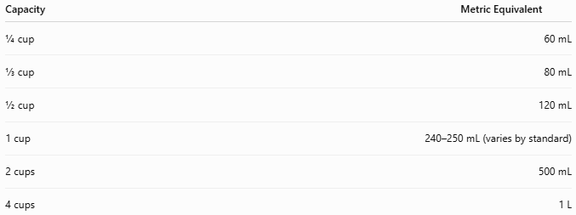
Capacity | Metric Equivalent
¼ cup | 60 mL
⅓ cup | 80 mL
½ cup | 120 mL
1 cup | 240–250 mL (varies by standard)
2 cups | 500 mL
4 cups | 1 L

Resolution
# Source: AI Source: Provided by: [Data Path: Persons Table -> ID Column: 1, Name_En Column: Motasem Essam] -> From: [ChatGPT] on [7/17/2026]
Typical graduation intervals:
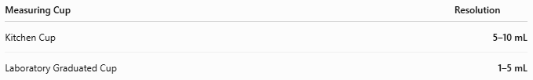
Measuring Cup | Resolution
Kitchen Cup | 5–10 mL
Laboratory Graduated Cup | 1–5 mL

How to Use a Measuring Cup
# Source: AI Source: Provided by: [Data Path: Persons Table -> ID Column: 1, Name_En Column: Motasem Essam] -> From: [ChatGPT] on [7/17/2026]
For Liquids
- Place the cup on a flat, level surface.
- Pour the liquid slowly.
- Bend to eye level.
- Read the bottom of the meniscus at the graduation mark.
For Dry Ingredients
- Fill the cup without compressing the ingredient (unless the recipe specifies otherwise).
- Level the top using a straight edge if required.
- Read the marked capacity.

Example
# Source: AI Source: Provided by: [Data Path: Persons Table -> ID Column: 1, Name_En Column: Motasem Essam] -> From: [ChatGPT] on [7/17/2026]
A glass measuring cup is filled until the liquid reaches the 250 mL graduation.
Measured volume:
250 mL

Accuracy
# Source: AI Source: Provided by: [Data Path: Persons Table -> ID Column: 1, Name_En Column: Motasem Essam] -> From: [ChatGPT] on [7/17/2026]
Accuracy depends on:
- Manufacturing quality
- Graduation spacing
- Proper reading technique
- User's eye level
Laboratory measuring cups provide approximate measurements and are less accurate than graduated cylinders or volumetric flasks.

Sources of Error
# Source: AI Source: Provided by: [Data Path: Persons Table -> ID Column: 1, Name_En Column: Motasem Essam] -> From: [ChatGPT] on [7/17/2026]
Instrument Errors
- Worn or faded graduations
- Manufacturing defects
- Deformation (plastic cups)

User Errors
- Reading above or below eye level (parallax error)
- Reading the top instead of the bottom of the meniscus
- Overfilling or underfilling
- Compressing dry ingredients unintentionally

Environmental Errors
- Temperature expansion of liquids
- Damaged or warped container

Applications
# Source: AI Source: Provided by: [Data Path: Persons Table -> ID Column: 1, Name_En Column: Motasem Essam] -> From: [ChatGPT] on [7/17/2026]
Measuring cups are used in:
- Home cooking
- Baking
- Food manufacturing
- Restaurants
- Schools
- Scientific education
- General laboratories
- Pharmaceutical preparation
- Chemical mixing

Advantages
# Source: AI Source: Provided by: [Data Path: Persons Table -> ID Column: 1, Name_En Column: Motasem Essam] -> From: [ChatGPT] on [7/17/2026]
A measuring cup:
- Is simple to use.
- Measures both liquids and dry ingredients.
- Is available in multiple capacities.
- Is inexpensive.
- Requires no power source.

Limitations
# Source: AI Source: Provided by: [Data Path: Persons Table -> ID Column: 1, Name_En Column: Motasem Essam] -> From: [ChatGPT] on [7/17/2026]
A measuring cup:
- Provides moderate rather than high precision.
- Is less accurate than laboratory volumetric glassware.
- Plastic markings may fade with time.
- Dry ingredient measurements depend on proper filling technique.

Comparison with Other Volume Measuring Instruments
# Source: AI Source: Provided by: [Data Path: Persons Table -> ID Column: 1, Name_En Column: Motasem Essam] -> From: [ChatGPT] on [7/17/2026]
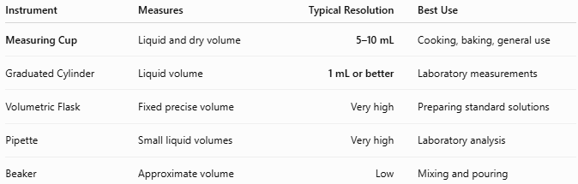
Instrument | Measures | Typical Resolution | Best Use
Measuring Cup | Liquid and dry volume | 5–10 mL | Cooking, baking, general use
Graduated Cylinder | Liquid volume | 1 mL or better | Laboratory measurements
Volumetric Flask | Fixed precise volume | Very high | Preparing standard solutions
Pipette | Small liquid volumes | Very high | Laboratory analysis
Beaker | Approximate volume | Low | Mixing and pouring

Care and Maintenance
# Source: AI Source: Provided by: [Data Path: Persons Table -> ID Column: 1, Name_En Column: Motasem Essam] -> From: [ChatGPT] on [7/17/2026]
To maintain accuracy:
- Wash after each use.
- Avoid scratching graduation marks.
- Do not expose plastic cups to excessive heat.
- Store carefully to prevent deformation.
- Replace cups with faded or unreadable graduations.

Common Mistakes
# Source: AI Source: Provided by: [Data Path: Persons Table -> ID Column: 1, Name_En Column: Motasem Essam] -> From: [ChatGPT] on [7/17/2026]
- Reading the liquid from above instead of at eye level.
- Ignoring the meniscus.
- Packing flour or sugar too tightly when measuring dry ingredients.
- Using a liquid measuring cup for fixed dry-cup capacities without following recipe guidance.
- Measuring while holding the cup in the air instead of placing it on a flat surface.

Key Points
# Source: AI Source: Provided by: [Data Path: Persons Table -> ID Column: 1, Name_En Column: Motasem Essam] -> From: [ChatGPT] on [7/17/2026]
- A Measuring Cup measures the volume of liquids and dry ingredients.
- Common types:
  - Plastic Measuring Cup
  - Glass Measuring Cup
  - Stainless Steel Measuring Cup
  - Laboratory Graduated Cup
- Common units:
  - mL
  - L
  - Cups
  - Fluid ounces
- Widely used in cooking, baking, laboratories, education, and food production.
- Accuracy depends on correct reading technique and proper handling.

Conclusion
# Source: AI Source: Provided by: [Data Path: Persons Table -> ID Column: 1, Name_En Column: Motasem Essam] -> From: [ChatGPT] on [7/17/2026]
A Measuring Cup is one of the most common and practical volume-measuring instruments, designed for accurately measuring liquids and dry ingredients in everyday and professional settings. Its graduated markings, ease of use, and availability in various materials and capacities make it indispensable in kitchens, laboratories, schools, and industrial food production. Although it does not provide the precision of laboratory volumetric glassware, it offers sufficient accuracy for most culinary, educational, and general measurement tasks when used correctly.

